Project Phase 3

Due: Thu Mar 20, 2025 11:59pmDue: Thu Mar 20, 2025 11:59pm

Ungraded, 50 Possible Points50 Points Possible

Attempt



In Progress

NEXT UP: Submit Assignment

Unlimited Attempts Allowed

Available: Mar 14, 2025 12:00pm until Mar 21, 2025 11:59pmAvailable: Mar 14, 2025 12:00pm until Mar 21, 2025 11:59pm

This is the third and the last phase of the project of this quarter. In this phase you will complete a partially implemented GUI application, BlackjackFrame, which allows user to play the complete game.

Here are detailed instructions:[Project-Phase3.pdf](https://bc.instructure.com/courses/2528645/files/266732208?wrap=1)

Here's the starter file: [gui_blackjack.py](https://bc.instructure.com/courses/2528645/files/266732209?wrap=1)

Here are some sample runs for the final version of the game:

When player's hand busts:

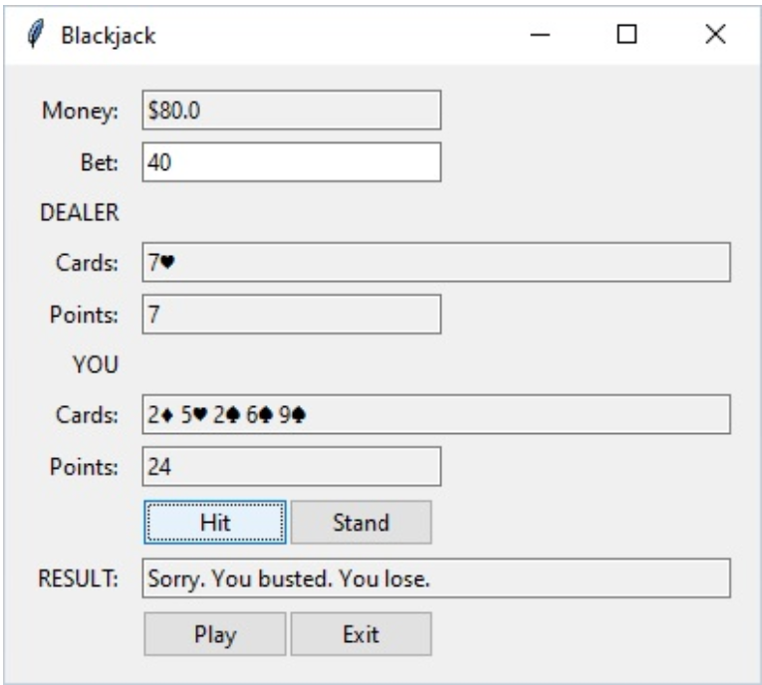

When player wins:

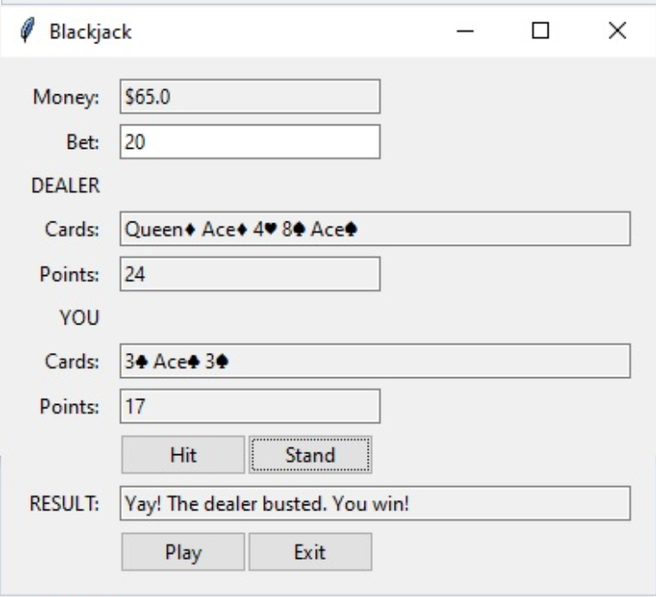

When player pushes:

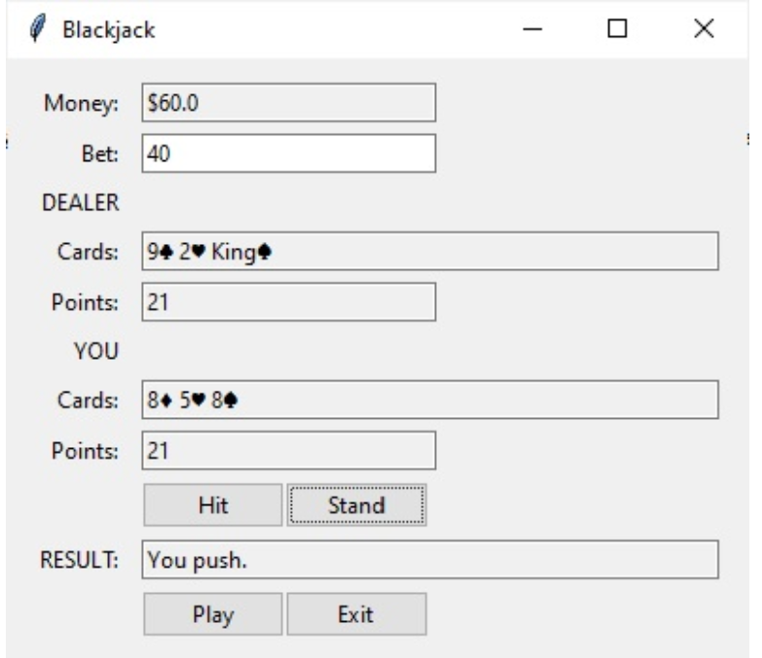

When dealer's hand busts:

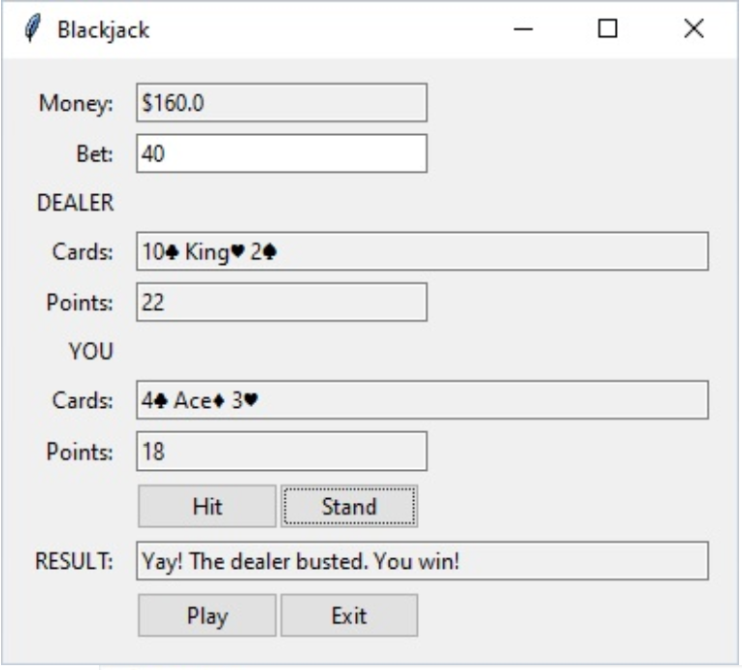

When player wins with a blackjack:

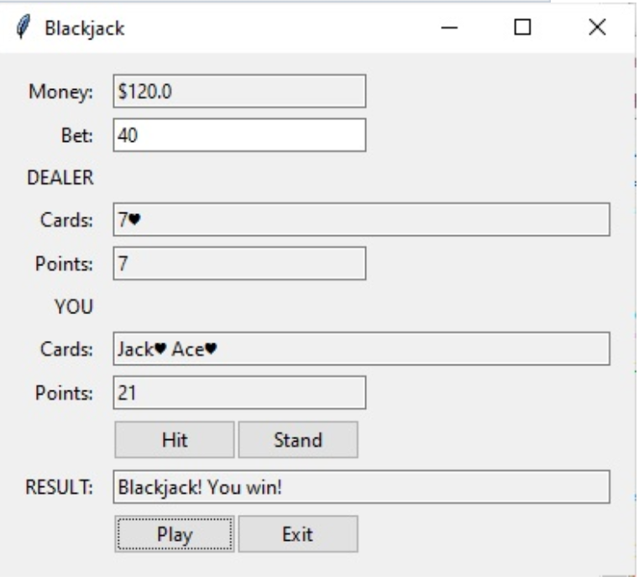

Don’t be discouraged by the length of the instructions or the rules of the game listed. Just follow the instructions and you will have no problem getting the game to work. This is a game you want players to want to play!! Make it a good experience for the player. Submit edited version of the  blackjack.py and gui_blackjack.py files with a  block-comment at the top.